Press Release: The Mouse House Director: Morgan Mainguy

The Mouse House

by Robert Ainsworth
Oct. 18-Nov. 3, 2018

Voted Best Production in 2012 by Theatre Ontario
DIRECTED BY MORGAN MAINGUY: Carson, a successful author, has arrived at a cottage somewhere in Ontario at the end of the fall season to write his latest book. He chose this time of year to be in complete isolation; with no phone, and away from his tormented life. Late one night, Carson is jolted awake by the sounds of an intruder climbing in through the window. He knocks the intruder out. The next morning Troy, an angry teenaged delinquent, regains consciousness and discovers Carson has chained him to a heavy metal bed. With unexpected revelations which turn the play on its head, these two fierce opponents come face to face with their inner demons and an emerging unspoken trust.
CAST:
BOBBY- Sandy Turcotte
CARSON- Richard Palimaka
TROY- Tom Abram
THOMAS- Harold G. Potter

Start time: 7:30 p.m.

Thursday, Friday, Saturday nights

DOMINO THEATRE
52 CHURCH STREET
KINGSTON, ONT.
K7M 1H3

Tickets available at:
The Grand Theatre box office 613-530-2050
Online at: www.kingstongrand.ca

Or:
At the Domino Theatre door for:
a) the night of the performance if tickets available
b) Cash, credit and debit now accepted at the Domino Theatre door.
d) Seniors and members $16 Thursdays only at the Domino Theatre door.

Adults: $20 Students: $10 Children: $10

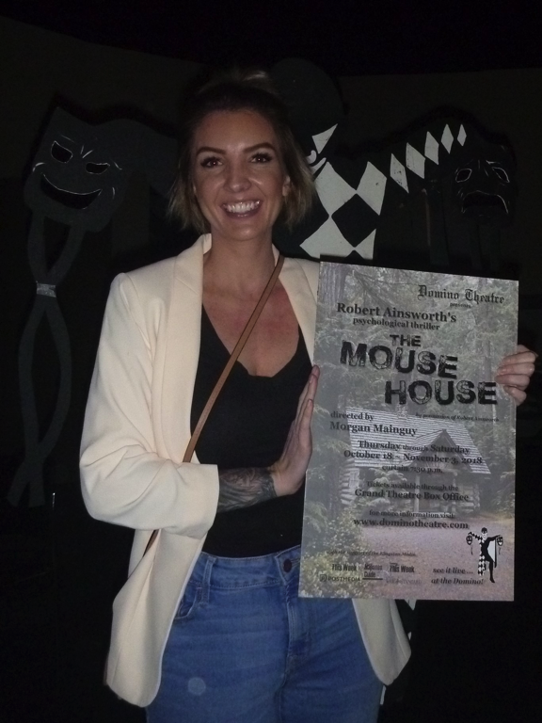
Director: Morgan Mainguy
