Domino Theatre Press Release: One Act Play Festival

JOIN US FOR THIS YEAR’S DOMINO ONE ACT PLAY FESTIVAL

Friday, July 5th, 2019
Saturday, July 6th, 2019

5 plays over 2 nights. Plays will be judged by 3 adjudicators. If you see all 5 shows, fill out a ballot and help the judges choose the winner.

Come Play by the Lake 11
One Act Festival
Domino Theatre
Friday July 5, 2019 7:30 pm
“Off My Block”, a poignant comedy by John Corrigan
“Cute and Cursed Cruise Lines”, an improvised farce by Amy Lucille Wilding and gang.

Saturday July 6, 2019
“The Chit Chat”, a comedy about growing older by Harry Jordan
“French Kisses” a comedy of confusion in Nice by Tony Houghton
“The Custodian”, a tender family drama by Craig Godfrey.

Please join us as five brand new plays are introduced to our audience.
Tickets through the Grand Theatre Box Office starting late May.
All adults $20.00 per evening and children and students $10.00.
613-530-2050 or the Grand website.www.kingstongrand.ca
The winner of our Festival will be chosen Saturday evening after the shows and will go on to represent Domino in Perth in November at the Eastern Ontario Drama League’s One Act Festival.

See it live. www,dominotheatre.com

Start time: 7:30 p.m.

Friday, Saturday nights

DOMINO THEATRE
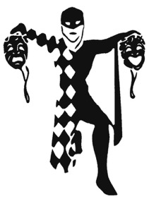
52 CHURCH STREET
KINGSTON, ONT.
K7M 1H3

Tickets available at:
The Grand Theatre box office 613-530-2050
Online at: www.kingstongrand.ca

Or:
At the Domino Theatre door for:
a) the night of the performances if tickets available
b) Cash, credit and debit now accepted at the Domino Theatre door.

Adults: $20 Students: $10 Children: $10

